ST0249   
AI & Machine Learning

Practical 6  
Introduction to Deep Learning



What you will learn / do in this lab

1. Explore Deep Learning concepts and applications
2. Conduct an Image application experiment using Deep Learning
3. Conduct a Sentiment Analysis experiment using Deep Learning

TAble of  
Contents

1. Overview 1

Introduction to deep learning 1

Applications of deep learning 2

2. Image Applications 4

Image recognition 4

Image restoration 7

3. NLP Application 9

Natural Language Processing (NLP) 9

Sentiment analysis 9

# 1. Overview

In this practical we will be exploring what is deep learning. We will also be running some online demonstrations that use deep learning on data that is unstructured (no rows, no columns, no attributes, no labels).

## Introduction to deep learning

Deep learning is part of a broader family of machine learning methods based on **learning data representations**, as opposed to task-specific algorithms. Learning can be supervised, semi-supervised or unsupervised. Deep learning neural networks have many layers (8 or more layers).

Deep learning is a class of machine learning algorithms that:

* use a cascade of multiple layers of nonlinear processing units for **feature extraction** and **transformation**. Each successive layer uses the output from the previous layer as input.
* learn in supervised (e.g., classification) and/or unsupervised (e.g., pattern analysis) manners.
* **learn multiple levels of representations** that correspond to different levels of abstraction; the levels form a **hierarchy of concepts**.

## Applications of deep learning

Deep learning stands out in its ability to handle large amounts of data and for unstructured data such as video, images, speech, audio and text in natural language.

The following are a list of top applications for Deep Learning:

* Automatic speech recognition: Voice Search & Voice-Activated Assistants
* Video analysis: Self-driving cars
* Image recognition
* Image restoration: super-resolution, automatic colourization of black and white photos
* Natural language processing: Sentiment analysis
* Automatic Machine Translation
* Recommendation systems
* Question answering system: Chatbots
* Automatic Image Caption Generation

**Activity**

* Take 15 minutes to explore this application.
* Use URL: <https://quickdraw.withgoogle.com/>



How it works:

Under the hood, the model takes sequences of strokes your draw on the canvas and feed into a combination of convolution layer and recurrent network. Finally, the class digits will be generated from the softmax output layer. And here is the illustration of the structure of the model.

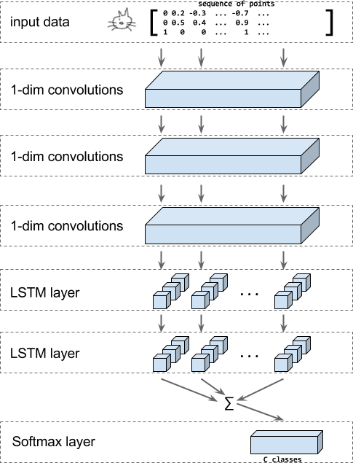

# 2. Image Applications

In the section, we will explore two application areas of deep learning related to images.

## Image recognition

Image recognition, in the context of machine vision, is the ability of software to identify objects, places, people, writing and actions in images.

Image recognition is used to perform a large number of machine-based visual tasks, such as labeling the content of images with meta-tags, performing image content search and guiding autonomous robots, self-driving cars and accident avoidance systems.

A common evaluation set for image classification is the MNIST database data set. MNIST is composed of handwritten digits and includes 60,000 training examples and 10,000 test examples.

**Activity**

* Take 15 minutes to explore this application.
* Use URL: <https://cs.stanford.edu/people/karpathy/convnetjs/demo/mnist.html>

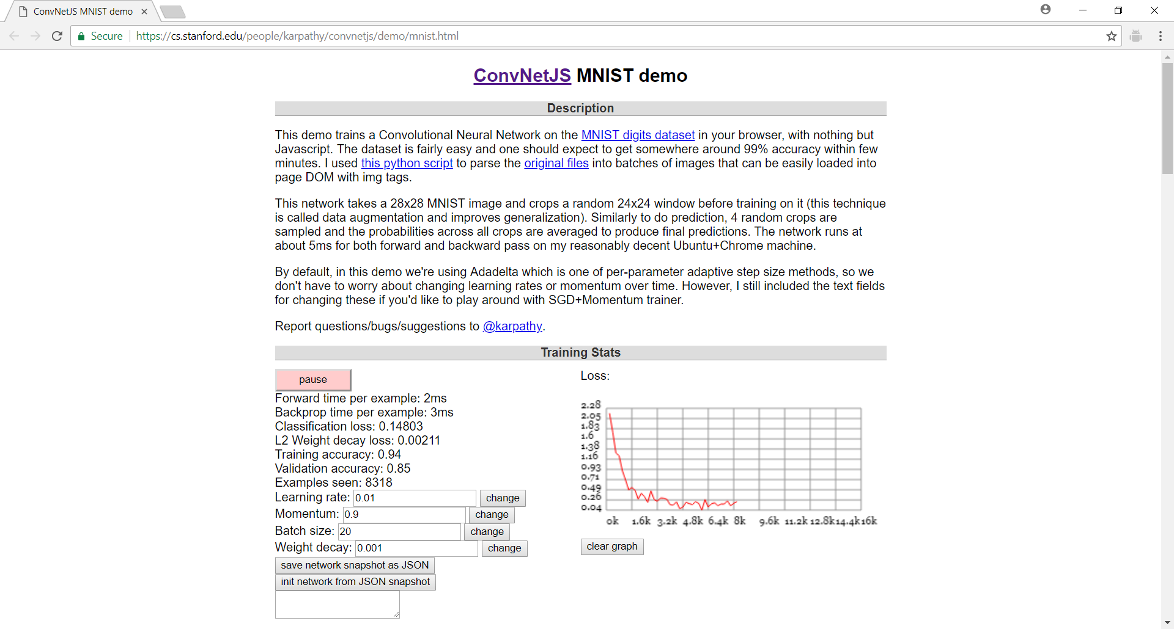

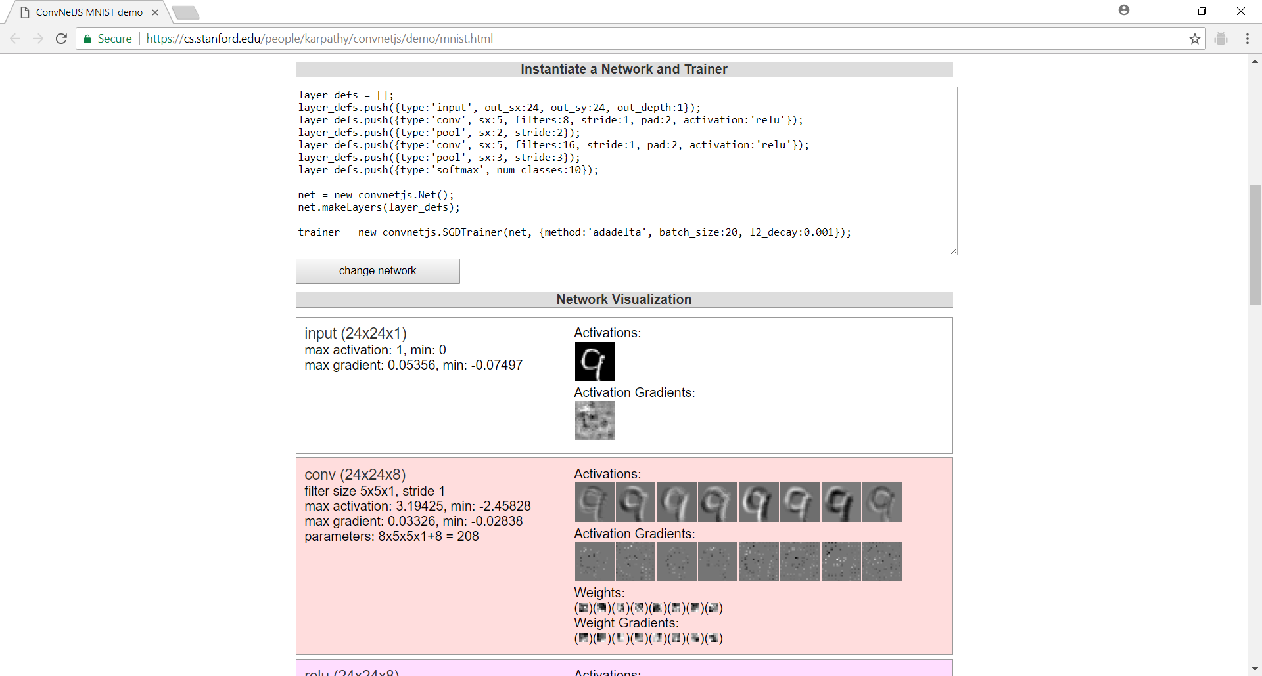

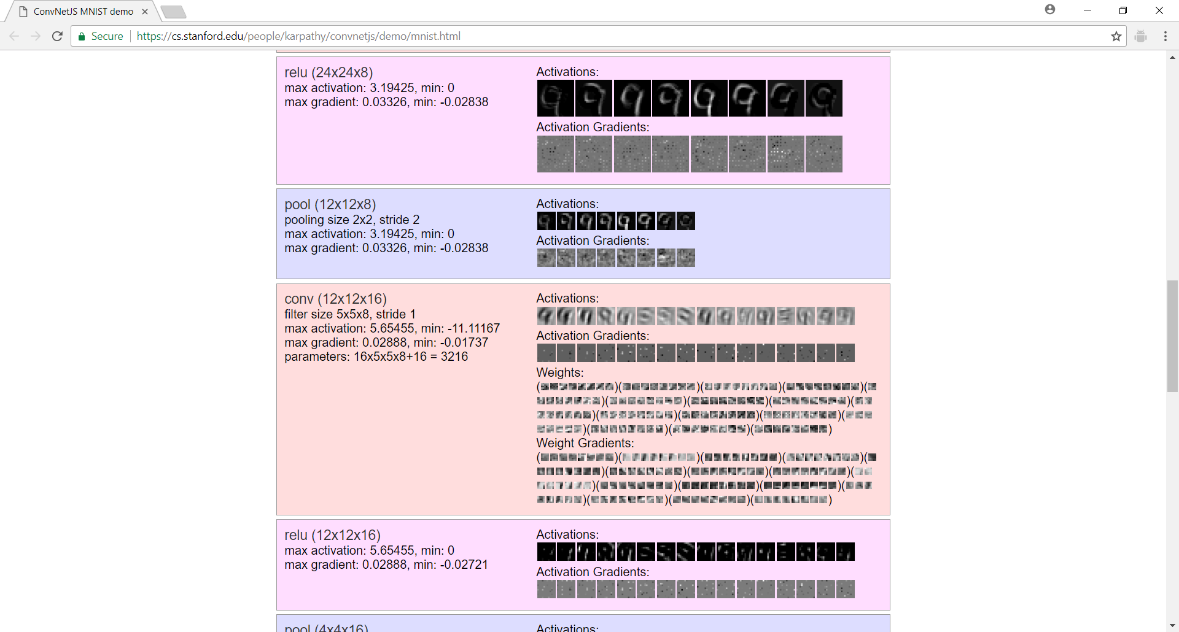

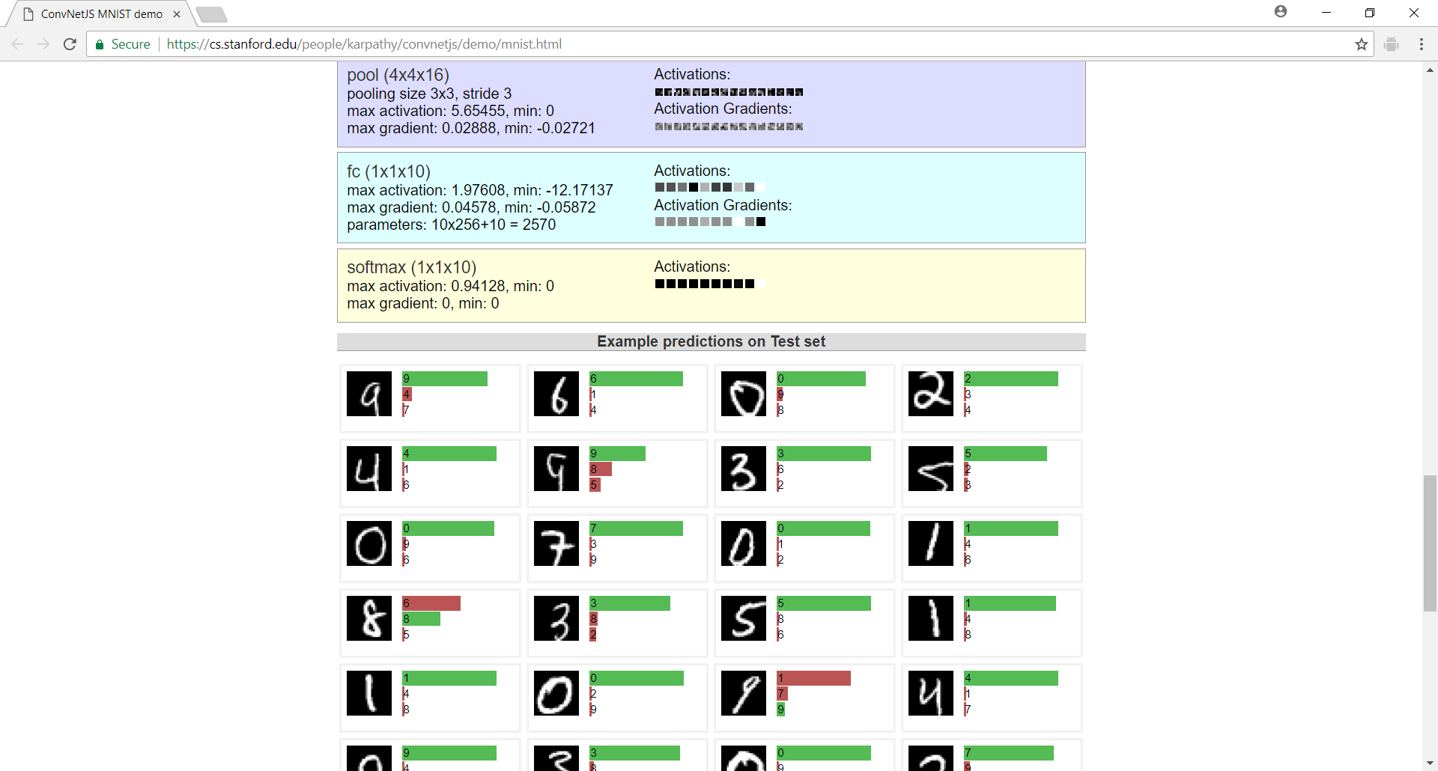

Note: Use chrome browser. Clear browser cache and reload if it does not start properly.

How it works:

ConvNetJS is a Javascript library for training Deep Learning models (Neural Networks) entirely in your browser. See documentation at: <https://cs.stanford.edu/people/karpathy/convnetjs/docs.html>

The network use for the demo is given by

layer_defs = [];

layer_defs.push({type:'input', out_sx:24, out_sy:24, out_depth:1});

layer_defs.push({type:'conv', sx:5, filters:8, stride:1, pad:2,  
 activation:'relu'});

layer_defs.push({type:'pool', sx:2, stride:2});

layer_defs.push({type:'conv', sx:5, filters:16, stride:1, pad:2,  
 activation:'relu'});

layer_defs.push({type:'pool', sx:3, stride:3});

layer_defs.push({type:'softmax', num_classes:10});

net = new convnetjs.Net();

net.makeLayers(layer_defs);

trainer = new convnetjs.SGDTrainer(net, {method:'adadelta', batch_size:20,   
 l2_decay:0.001});

## Image restoration

View and edit this document in Word on your computer, tablet, or phone. You can edit text; easily insert content such as pictures, shapes, or tables; and seamlessly save the document to the cloud from Word on your Windows, Mac, Android, or iOS device.

**Activity**

* Take 15 minutes to explore this application.
* Use URL:   
  <https://transcranial.github.io/keras-js/#/image-super-resolution>

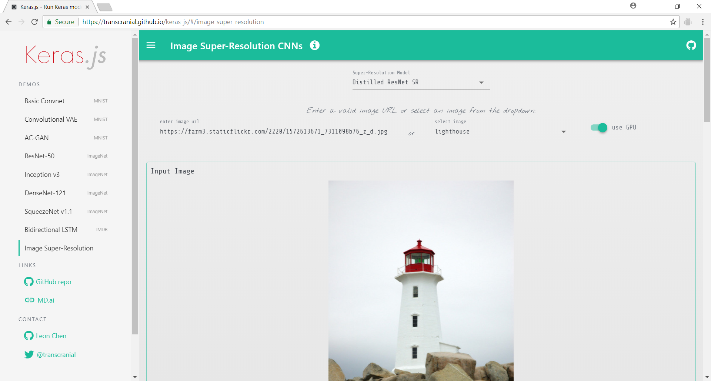

How it works:

See URL: <https://github.com/titu1994/Image-Super-Resolution>

Implementation of Image Super Resolution CNN in Keras from the paper [*Image Super-Resolution Using Deep Convolutional Networks*](https://arxiv.org/pdf/1501.00092v3.pdf).

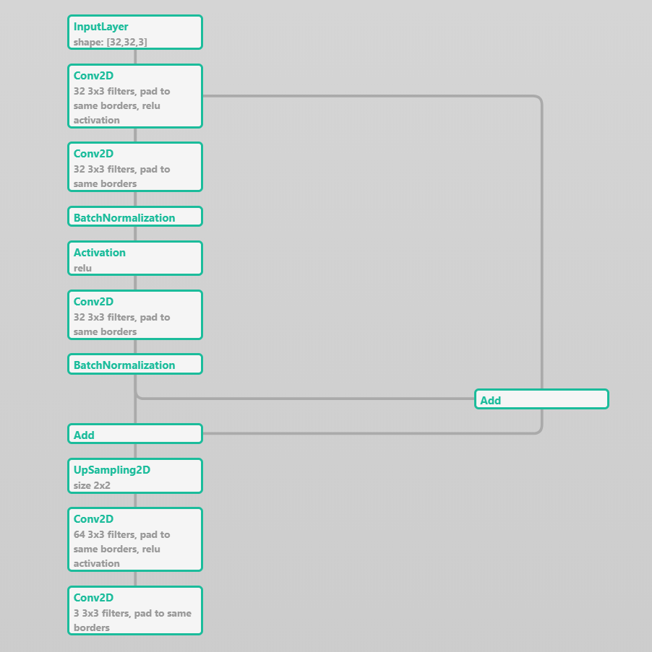

# 3. NLP Application

In this section we will be using deep learning for a different kind of data involving sequences. Unlike image data where pixels in the neighbourhood of each other are likely to be related, in sequence data the ordering of the data is import. Consider the sentence: “grandmother bit the dog” vs “dog bit the grandmother”: the same words are used but they have completely different meanings depending on the sequence of words.

## Natural Language Processing (NLP)

Natural-language processing (NLP) is an area of computer science and artificial intelligence concerned with the interactions between computers and human (natural) languages, in particular how to program computers to fruitfully process large amounts of natural language data.

Challenges in natural-language processing frequently involve speech recognition, natural-language understanding, and natural-language generation.

## Sentiment analysis

Sentiment analysis (opinion mining or emotion AI) refers to the use of natural language processing, text analysis, computational linguistics, and biometrics to systematically identify, extract, quantify, and study affective states and subjective information.

Sentiment analysis is widely applied to voice of the customer materials such as reviews and survey responses, online and social media, and healthcare materials for applications that range from marketing to customer service to clinical medicine.

A basic task in sentiment analysis is classifying the **polarity** of a given text at the document, sentence, or feature/aspect level — whether the expressed opinion in a document, a sentence or an entity feature/aspect is **positive**, **negative**, or **neutral**.

Advanced sentiment classification looks, for instance, at emotional states such as "angry", "sad", and "happy".

**Activity**

* Take 15 minutes to explore this application.
* Use URL:   
  <https://transcranial.github.io/keras-js/#/imdb-bidirectional-lstm>

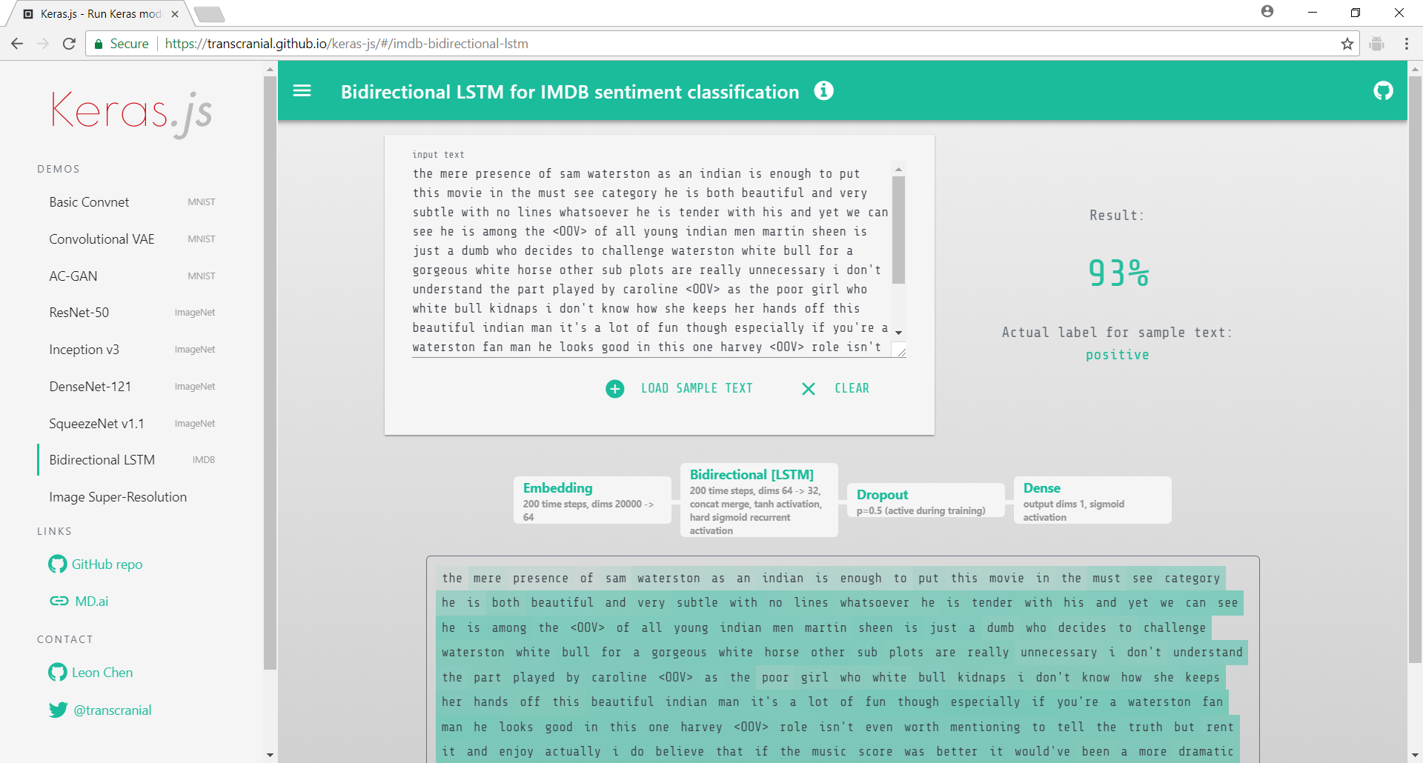

How it works:

Recurrent neural networks are a subclass of neural networks, designed to perform a sequences recognition or prediction. They have a flexible number of inputs and they allow cyclical connections between their neurons. This means that they are able to remember previous information and connect it to the current task.

Long Short Term Memory networks (LSTM) are a subclass of RNN, specialized in remembering information for a long period of time. More over the Bidirectional LSTMs keep the contextual information in both directions.

A bidirectional LSTM is used to implement a deep recurrent neural network. It checks for sequences of words that are used to train the neural network for positive sentiment and negative sentiment.

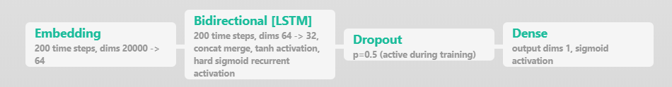

The Dropout layer is added to prevent overfitting.

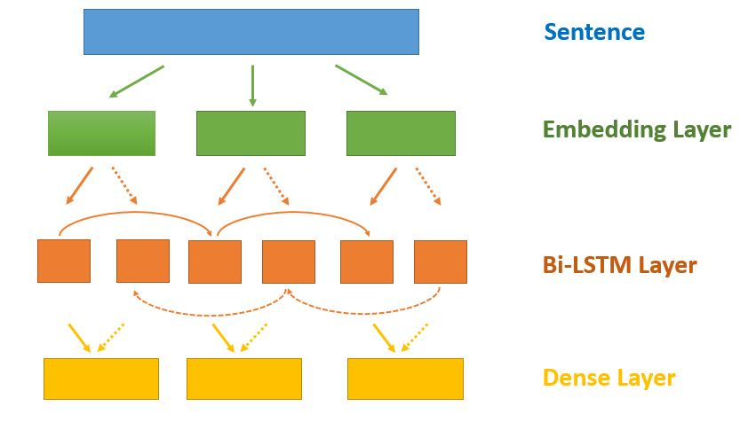

As described in the image above, we need to have three layers:

* **Embedding Layer** - modifies the integer representation of words into dense vectors
* **Bidirectional LSTM Layer** - connects two hidden layers of opposite directions to the same output
* **Dense Layer** - output layer with softmax activation

See <https://machinelearningmastery.com/use-word-embedding-layers-deep-learning-keras/> for explanation of word embedding